How to download docker images through docker container :-

Command – docker pull selenium/hub

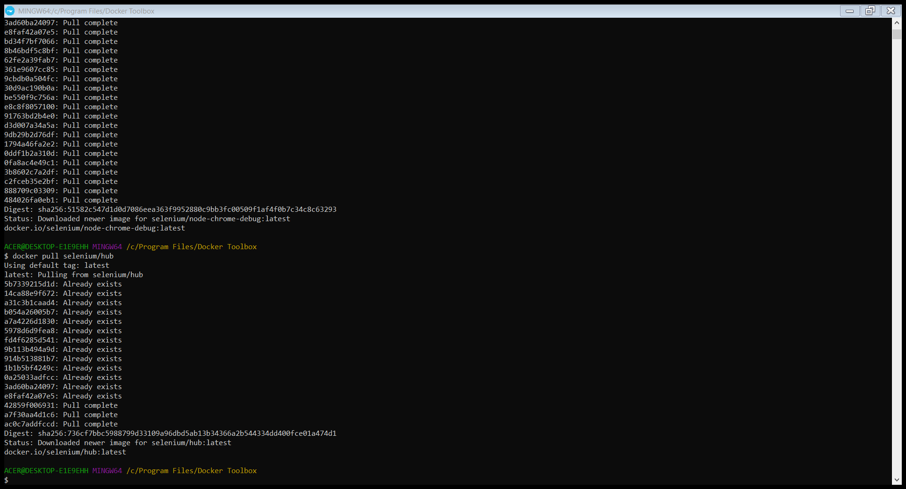

Pull and download completed

Command – docker pull selenium/node -chrome-debug

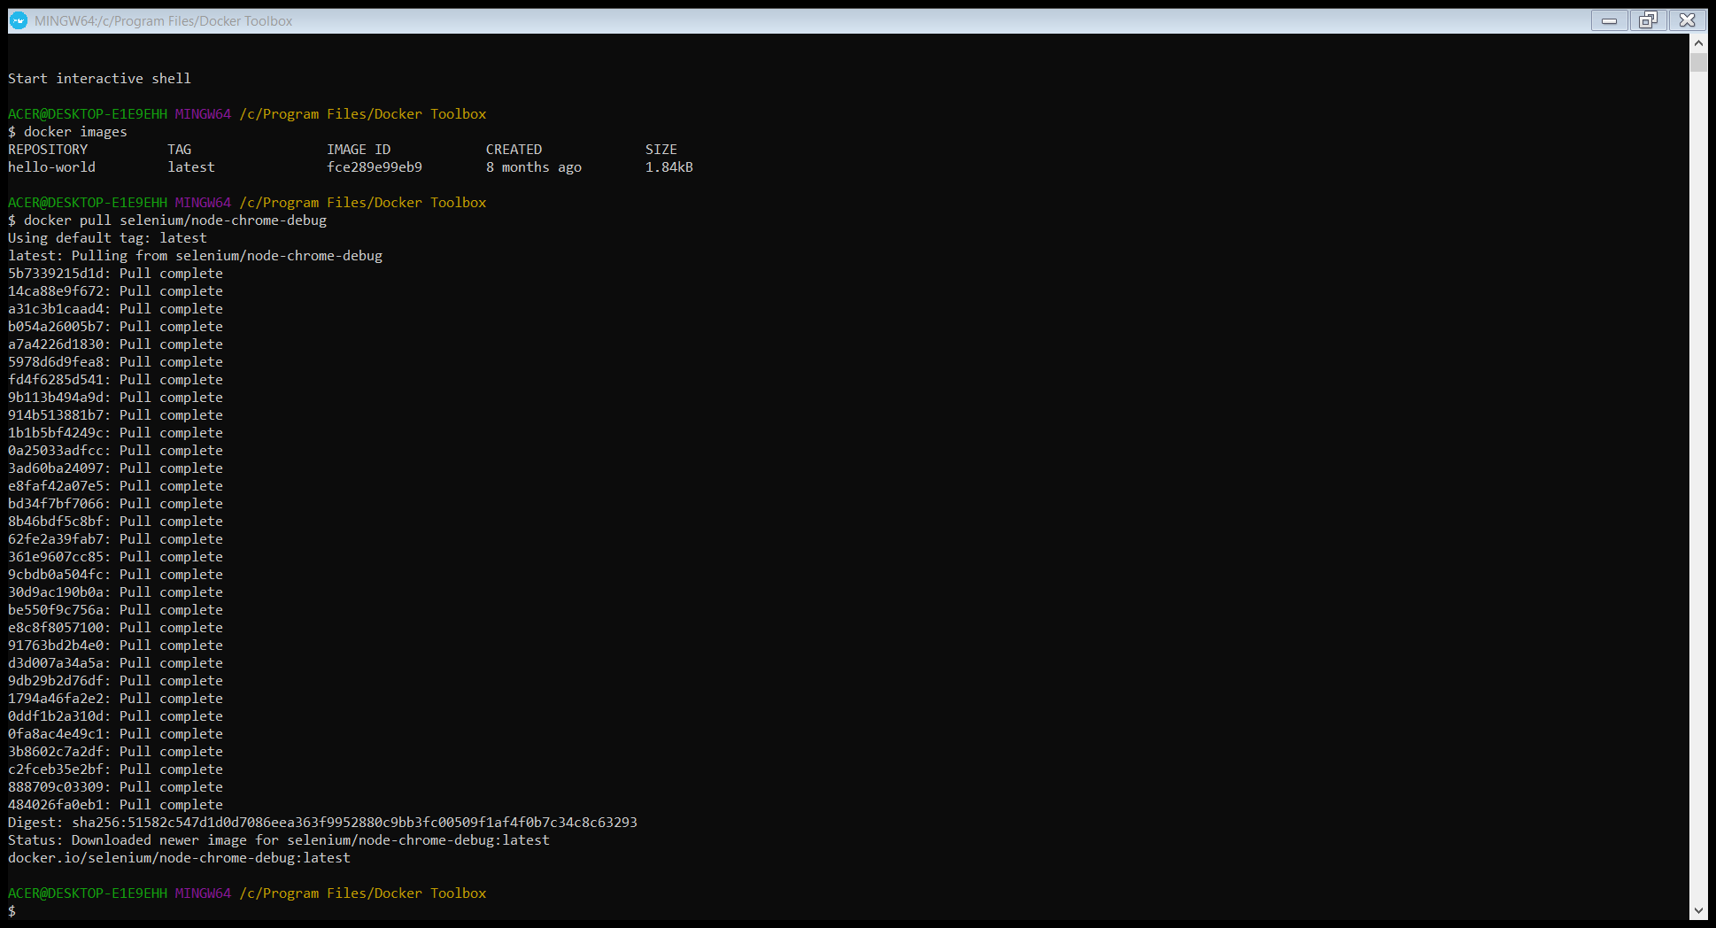

Run the following command

Docker run -d-p 4545:4444 – name seleniumjitu-hub selenium/hub

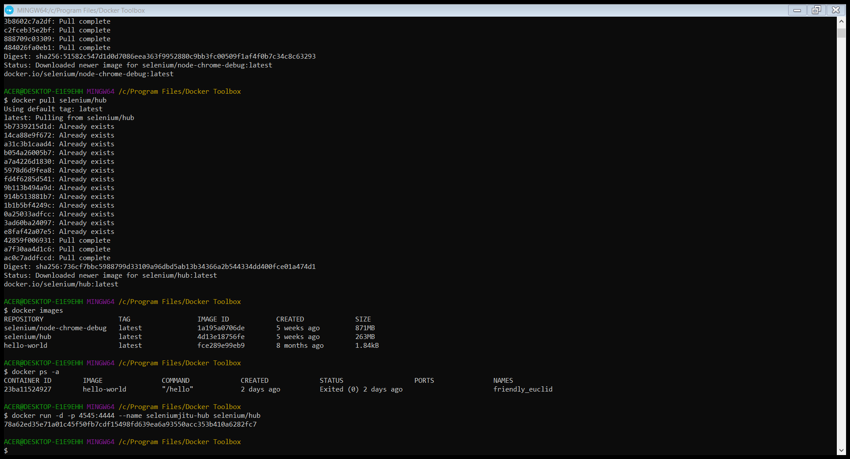

Container got created

To check all the containers

Docker ps -a

Run the following command to create hub

docker run -d-P –link seleniumjitu-hub:hub selenium/node –chrome -debug

Install vnc viewer to login the container

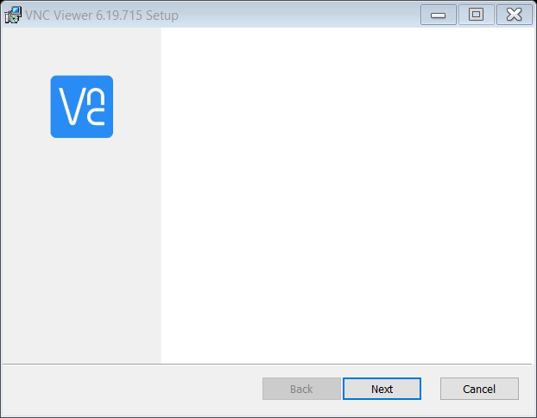

Open the set up

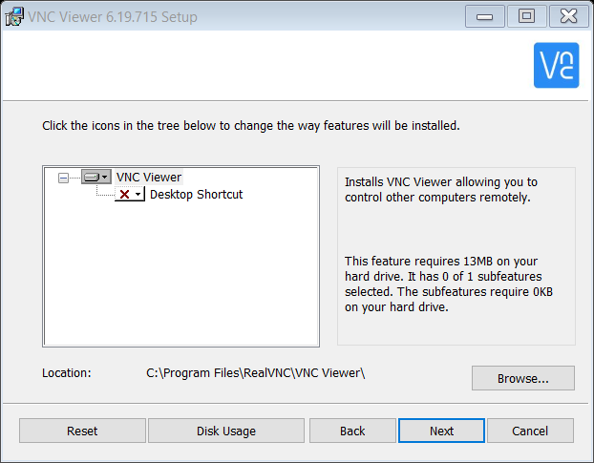

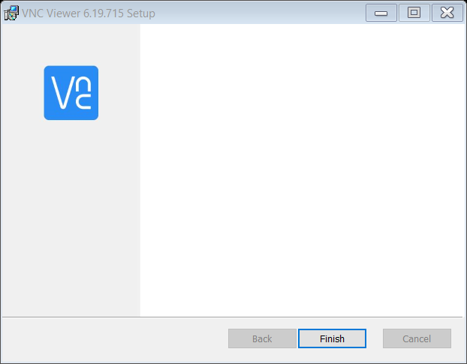

Login to vnc viewer

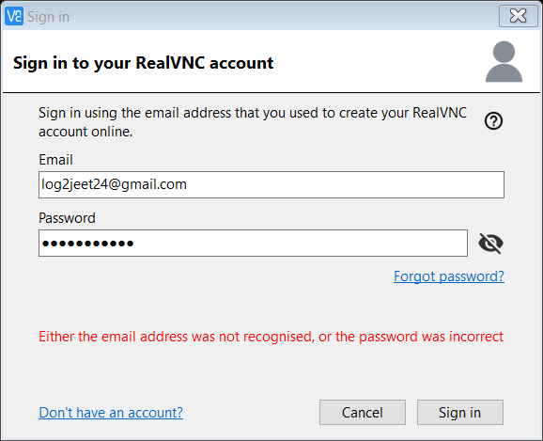

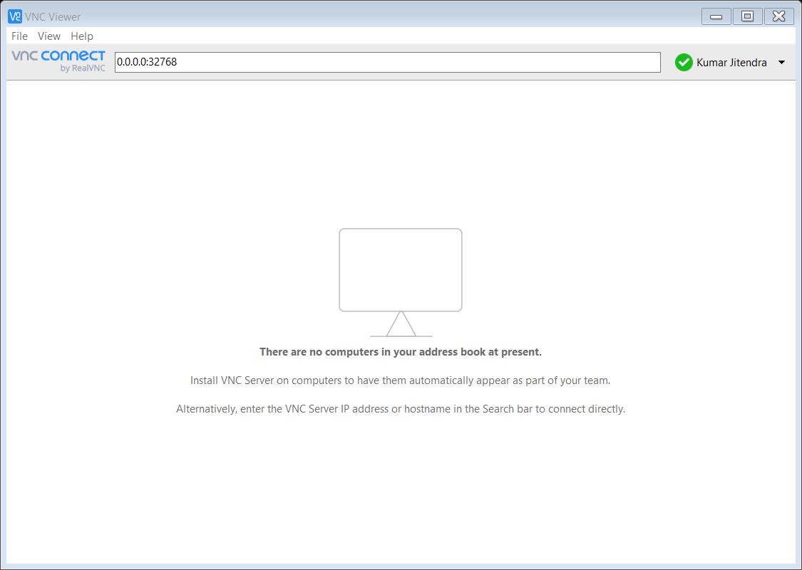

Give the url of docker container

Try alternate solution

Type docker network ls

Run the following command

docker network create -d bridge jitendra

